From:   <http://www.zerohedge.com/news/2015-09-03/flashpoint-white-house-confirms-russian-presence-syria-warns-it-destabilizing>

**Flashpoint: White House Confirms Russian Presence In Syria, Warns It Is "Destabilizing"**

[Tyler Durden's picture](http://www.zerohedge.com/users/tyler-durden)

Submitted by [Tyler Durden](http://www.zerohedge.com/users/tyler-durden) on 09/03/2015 23:35 -0400

* [**Middle East**](http://www.zerohedge.com/taxonomy_vtn/term/11126)

* [**Reality**](http://www.zerohedge.com/taxonomy_vtn/term/12218)

* [**Saudi Arabia**](http://www.zerohedge.com/taxonomy_vtn/term/11356)

* [**Turkey**](http://www.zerohedge.com/taxonomy_vtn/term/10360)

* [**Twitter**](http://www.zerohedge.com/taxonomy_vtn/term/8993)

* [**Twitter**](http://www.zerohedge.com/taxonomy_vtn/term/12423)

* [**White House**](http://www.zerohedge.com/taxonomy_vtn/term/223)

[inShare](javascript:void(0);)20

Two days ago [we reported](http://www.zerohedge.com/news/2015-08-31/russian-military-forces-arrive-syria-set-forward-operating-base-near-damascus)something which we had anticipated for a long time but nonetheless did not expect to take shape so swiftly: namely, that with Assad's regime close to collapse and fighting a war on three different fronts (one of which is directly supported by US air and "advisor" forces), Putin would have no choice but to finally intervene in the most anticipated showdown in recent history as "Russian fighter pilots are expected to begin arriving in Syria in the coming days**, and will fly their Russian air force fighter jets and attack helicopters against ISIS and rebel-aligned targets within the failing state**."

This was indirectly confirmed the very next day when an al-Nusra linked Twitter account [posted pictures of a Russian drone](https://twitter.com/green_lemonnn/status/639017115077484544/photo/1?ref_src=twsrc%5etfw)and a Su-34 fighter jet - the kind which is not flown by the Syrian air force - flying over the Nusra-controlled western idlib province.

[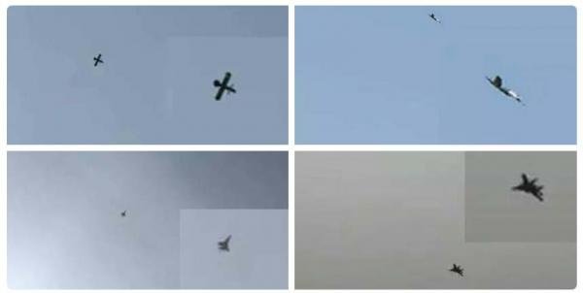](http://www.zerohedge.com/sites/default/files/images/user5/imageroot/2015/08/russian%20jets.jpg)

Another [twitter account](https://twitter.com/ValkryV/status/638377803155656705/photo/1)said to have captured Russian soldiers in Zabadani "while fighting for Assad"

[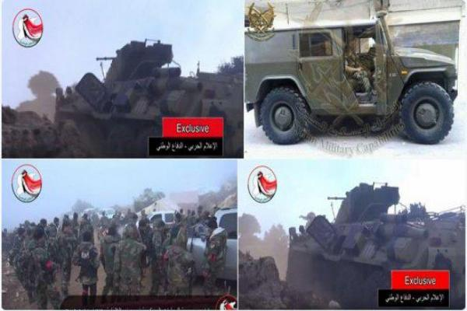](http://www.zerohedge.com/sites/default/files/images/user5/imageroot/2015/08/russian%20ground%20forces.jpg)

Also, one day after our report, the [Telegraph reported](http://www.telegraph.co.uk/news/worldnews/middleeast/syria/11840713/Russian-troops-fighting-alongside-Assads-army-against-Syrian-rebels.html)that "Syrian state TV reportedly broadcasts footage of Russian soldiers and armoured vehicle fighting alongside pro-Assad troops." According to the article, "the video footage claimed to show troops and a Russian armoured vehicle fighting Syrian rebels alongside President Bashar al-Assad's troops in Latakia. It is reportedly possible to hear Russian being spoken by the troops in the footage."

It added that "a Russian naval vessel was photographed heading south through the Bosphorus strait carrying large amounts of military equipment, according to social media and a shipping blog" while "an unnamed activist with the Syrian rebel group the Free Syrian Army told The Times: “**The Russians have been there a long time.**"

*"There are more Russian officials who came to Slunfeh in recent weeks. We don’t know how many but I can assure you there has been Russian reinforcement.” "*

Then earlier today we got the closest thing to a confirmation from the [White House itself which confirmed](http://www.telegraph.co.uk/news/worldnews/middleeast/syria/11843030/White-House-monitoring-reports-Russian-military-is-in-Syria.html?utm_source=dlvr.it&utm_medium=twitter)that "**it was closely monitoring reports that Russia is carrying out military operations in Syria, warning such actions, if confirmed, would be "destabilising and counter-productive.**"

Obama spokesman Joshn Earnest essentially confirmed Russia was already operating in Syria when he said that "we are aware of reports that Russia may have deployed military personnel and aircraft to Syria, and we are monitoring those reports quite closely."

"Any military support to the Assad regime for any purpose, whether it's in the form of military personnel, aircraft supplies, weapons, or funding, **is both destabilising and counterproductive**."

And another confirmation: "**a US official confirmed that "Russia has asked for clearances for military flight to Syria,"**but added "**we don't know what their goals are**."

**"Evidence has been inconclusive so far as to what this activity is**."

Other reports have suggested Russia has targeted Islamic State group militants, who have attacked forces loyal to Russian-backed Syrian leader Bashar al-Assad.

Both the White House and the Pentagon refused to say whether they had intelligence suggesting the reports were accurate.

Of course, what is left unsaid is that since Russia is there under the humanitarian pretext of fighting the evil ISIS, the same pretext that the US, Turkey, and the Saudis are all also there for, when in reality everyone is fighting for land rights to the most important gas pipeline in decades, the US is limited in its diplomatic recoil.

Indeed as we [sarcastically said last week](http://www.zerohedge.com/news/2015-08-31/russian-military-forces-arrive-syria-set-forward-operating-base-near-damascus): "See: the red herring that is ISIS can be used just as effectively for defensive purposes as for offensive ones. And since the US can't possibly admit the whole situation is one made up farce, it is quite possible that the world will witness its first regional war when everyone is fighting a dummy, proxy enemy which doesn't really exist, when in reality everyone is fighting everyone else!"

* * *

Which now effectively ends the second "foreplay" phase of the Syrian proxy war (the first one took place in the summer of 2013 when in a repeat situation, Russia was supporting Assad only the escalations took place in the naval theater with both Russian and US cruisers within kilometers of each other off the Syrian coast), which means the violent escalation phase is next. It also means that Assad was within days of losing control fighting a multi-front war with enemies supported by the US, Turkey and Saudi Arabia, and Putin had no choice but to intervene or else risk losing Gazprom's influence over Europe to the infamous Qatari gas pipeline which is what this whole 3 years war is all about.

Finally, it means that the European refugee crisis, which is a direct consequence of the ISIS-facilitated destabilization of the Syrian state (as a reminder, ISIS is a US creation meant to depose of the Syrian president as leaked Pentagon documents have definitively revealed) is about to get much worse as 2013's fabricated "chemical gas" YouTube clip will be this years "Refugee crisis." It will be, and already has been, blamed on Syria's president Assad in order to drum up media support for what is now an inevitable western intervention in Syria.

The problem, however, has emerged: Russia is already on the ground, and will hardly bend over to any invading force.

Finally, while we have no way of knowing how the upcoming armed conflict will progress, now may be a safe time to take profits on that [oil short we recommended](http://www.zerohedge.com/news/2014-10-10/why-oil-plunging-other-part-secret-deal-between-us-and-saudi-arabia)back in October, as the geopolitical chess game just shifted dramatically, and with most hedge funds aggressively short, any realization that the middle east is suddenly a far more violent powderkeg - one which may promptly include the Saudis in any confrontation - could result in an epic short squeeze.